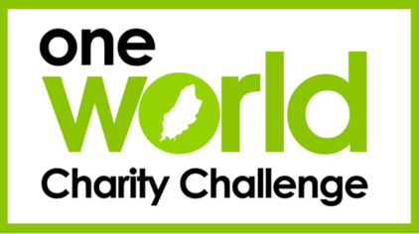
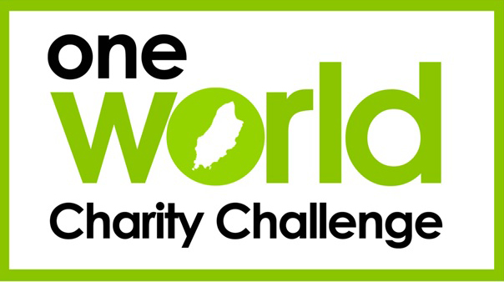
CHARITY INFORMATION
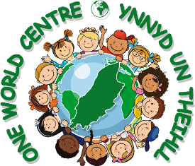
Please nominate ONE TEAM MEMBER to email your first, second and third charity choices, in order of preference
by Monday 10th October
- Charity allocation will be made randomly, shortly after this date, based as closely as possible on the charity choices you have requested
- We will help you to choose a suitable charity if you are not allocated one of your first three choices

Please email your choices, from the school email address of your team leader, copying in your school OWCC link teacher, to:
oneworldcharitychallenge@gmail.com
We need to know your NAMES,
which SCHOOL you are from
and your THREE CHOICES.

I will email you to let you know which charity you have been allocated. If you have not heard from me by 15th October, please get in contact.

If there is a particular area of charity work that you are interested in (e.g. health or education) please let me know in your email. This will help me to allocate a charity if you do not receive one of your first three choices.

All charities are listed on our website: www.oneworldcharitychallenge.com

Helen Kneale, OWCC Project Officer
oneworldcharitychallenge@gmail.com

